**DJ Kast’s Arctic Science Adventure**

Be part of the USC Young Scientists Program Director Ms. DJ Kast’s research trip to the Arctic. She will be going to the Arctic and wants to take some of your student’s science artwork with her on her Arctic Research Expedition!

She will be looking at microbes (bacteria and viruses) in the Arctic Freshwater at a research station within the Arctic Circle called Toolik. She will be working with Dr. George Kling and Dr. Byron Crump on a project that looks at how microbes affect various water sources in the environment and how they contribute to climate change on a global scale.

Each YSP classroom will be creating a large flag that represents their class and what they know about Polar Science. Each classroom must have the YSP Program, YSP TA, classroom teacher, and the school along with a **small drawing or text from every student relating to what they know about polar science.**

Students will also create their own Arctic postcard on paper that will be collected and also taken up to the Arctic. Students will receive their cards back through their 4th or 5th grade teacher at the end of the summer. On the front of the post card is a picture of the research base and its location in the Northern most part of Alaska and a demonstration of where it is in the Arctic Circle.

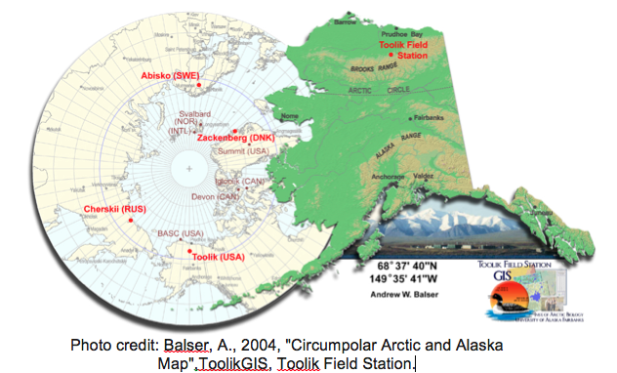

On the postcard- which looks like the image on the right. 🡪🡪🡪🡪🡪🡪🡪🡪🡪🡪🡪

* **Each student should write a question they have about the Arctic Journey to Toolik**
* **Put a drawing of himself or herself as a polar scientist.**

Thank you for joining me on my expedition to Toolik Research Station in the Arctic! I look forward to seeing your amazing designs! You can follow my adventure on the link below. **TA’s PLEASE TAKE PHOTOS! Creation, Final Product, Class Photo etc.**

<https://www.polartrec.com/expeditions/microbial-changes-in-arctic-freshwater-2016>

-DJ Kast