Graphing A Vertical Profile in McMurdo Sound, Antarctica

The pictures below show data readings from a water quality sensor as it moved towards the seafloor in McMurdo Sound. Look at the data and create a table and graphs to show how temperature, salinity, dissolved Oxygen and pH change in a water column over time. Note that depth refers to the distance from the surface of the water, and is recorded from the top of the graph down.

Raw Data:

Depth: 1 m  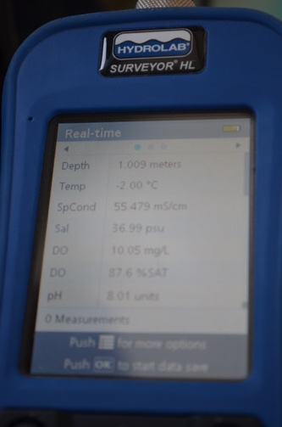 | Depth: 2 m  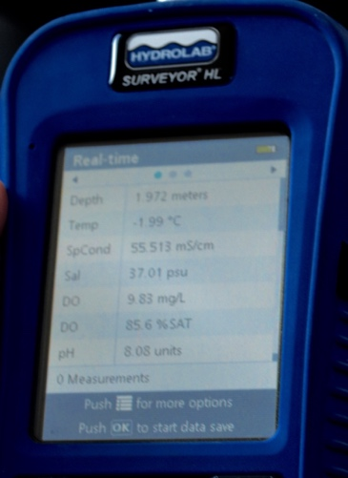 | Depth: 3 m  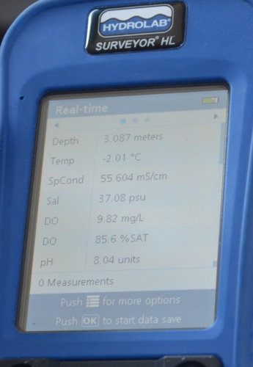
Depth: 4 m  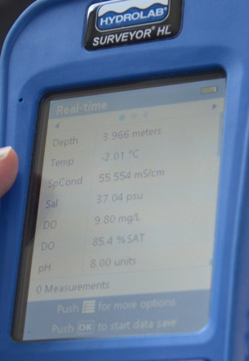 | Depth: 5 m  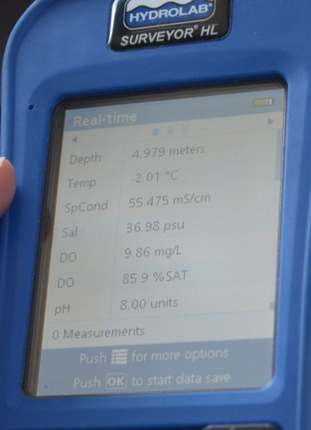 | Depth: 6 m  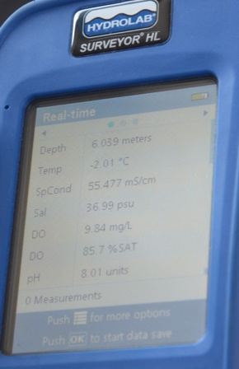
Depth: 7 m  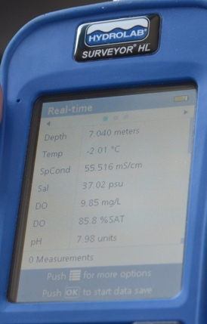 | Depth: 8 m  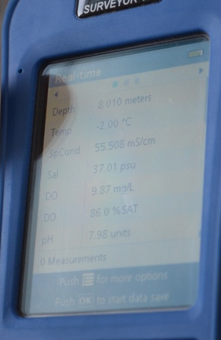 | Depth: 9 m  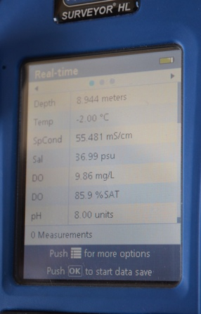

Data Table:
Create a data table in the space below to organize the data. You will be creating vertical profiles (graphs) for temperature, salinity (use psu), dissolved Oxygen (use % saturated), and pH.

Vertical Profiles:
Use your data tables to create vertical profiles for temperature, salinity, dissolved Oxygen and pH. Remember that depths are measured from the surface of the water, so the shallower the depth, the higher on the y axis it should be recorded.
Water Depth (m)
1 m

2 m

3 m

4 m

5 m

6 m

7 m

8 m

9 m

Temperature (°C)

Water Depth (m)
1 m

2 m

3 m

4 m

5 m

6 m

7 m

8 m

9 m
Salinity (psu)

Water Depth (m)
1 m

2 m

3 m

4 m

5 m

6 m

7 m

8 m

9 m
Dissolved Oxygen (% SAT)

Water Depth (m)
1 m

2 m

3 m

4 m

5 m

6 m

7 m

8 m

9 m

pH (units)
Conclusion Questions:

- What changes do you notice as the water gets deeper?

- Why do you think these changes occur?

- How do you think these measurements would be different in warmer water?

