Global Snow Cover Worksheet

1. Go to the Global Snow Lab website (http://climate.rutgers.edu/snowcover/) and begin your survey of available data resources by clicking on “Northern Hemisphere Visible Satellite Charts - Daily.”

What date are you looking at? ______________________

Describe the map output: (what do the colors mean, where is the greatest snow cover, etc).

Use the arrow keys to search previous days. Click back 5 days and describe any changes: (be sure to provide the location of these changes.

2. While you are looking at the Northern Hemisphere Snow Cover, click on “Viewing Departure.”

What do the colors mean?

Describe the departures you see for the date listed above.

Next, click on “See Full Climatology.” Refer to “Monthly Climatology” listed above under “Terms” to determine what the colors refer to, and click on “Documentation” to learn even more about how these maps are created.

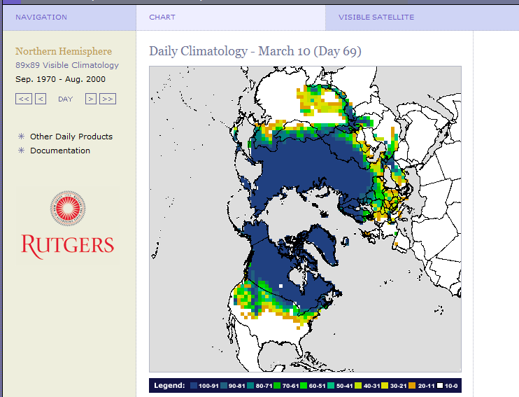

Figure 2. Example of Full Climatology output.

Describe the changes in your map over the data period. (ex: has the N.H. snow extent increased or decreased over the study period and if so, note the locations that have experienced changes)

3. Go back to the homepage, and under Northern Hemisphere Visible Satellite Charts explore the Weekly N.H snow charts. Use the back arrows to explore a time series for the weekly charts. Select a time period of at least 6 weeks, and explore the charts for that time period.

What was the time period you explored? ________________________________

What changes did you see over that time period?

4. Go back to the homepage, and under “Northern Hemisphere Visible Satellite Charts” explore the Monthly N.H snow charts. Use the back arrows to explore a time series for the monthly charts. Select a time period of at least 12 months, and explore the snow extent, departures, and climatology chart for that time period.

What was the time period you explored? ________________________________

What changes did you see over that time period? (be sure that you understand the color scales in the legend!)

5. Go back to the homepage and under “Graphs” click on “Snow Anomalies.” Toggle among the Northern Hemisphere, Eurasia and North America graphs.

What do the colors on the maps refer to?

Describe the vertical axis of the graphs.

List 3 specific observations of the Northern Hemisphere graphs

1.

2.

3.

Compare and contrast the Eurasia & North American graphs

Compare:

Contrast:

6. Go back to the homepage and under “Tabular” click on “Weekly.” While here look at the data for this year and half of last year and note the changes over this time period in each of the locations. Note that the data is in millions of square kilometers.

What is the general trend in data over this time period for each of these locations? Which of the locations in the Northern Hemisphere appears to show the greatest change over time?

7. Go back to the homepage and under “North America” click on “Station Pentads.” Once you are there click on “Documentation.” Read the description on the data used to create these charts. Use the space below to briefly describe the how these charts are created.

Go back to the charts under Station Pentads and explore Interpolated Station, Blend Interpolated, Gridded Station, Blend Gridded charts. Note the color scales and chart legends. Describe each of the charts selecting the same date for each.

What date did you choose? ______________________________

Describe the characteristics of the Interpolated Station chart.

Describe the characteristics of the Blend Interpolated Station chart.

Describe the characteristics of the Gridded Station chart.

Describe the characteristics of the Blend Gridded Station chart.

8. Select one of the above charts, and explore a time series of 10 pentads (1 pentad is the same as a 5 day period) for that chart. What are the dates of your time series?

Start date & pentad number: __________________________________________

End date & pentad number: __________________________________________

Describe the changes you see:

9. Now that you’ve explored the available data in chart, graphs, and tabular forms for different lengths of time and over different regions in the Northern Hemisphere, answer the following questions. Refer back to the appropriate resource for assistance.

In which season did you see the greatest changes over time? _____________________

Explain. Which data did you use to support your answer?

In which region in the Northern Hemisphere did you see the greatest changes over
time?________________________

Explain. Which data did you use to support your answer?

From your knowledge of global climate, suggest & explain at least 3 separate reasons
for the differences you stated above.

1.

2.

3.

Problem Exploration:
10. You are a climate scientist and have been asked to prepare a statement about changes in the snow cover in the United States over the past 10 years. You remember that the Rutgers University Global Snow Lab has a high resolution data in charts, graphs, and tabular forms. Which datasets from this resource will you use and why? Explain your procedure for creating this report. (You do not have to create the report!)

Analysis:
Now it is your turn to use the data to answer a question that you have developed related to changes in the Northern Hemispheric Snow Cover over time. Type your responses on a separate piece of paper.

• My question is:

• I will use the following data to answer my question:

• I will be examining these dates:

• Analyze your data in relationship to your question.

• Draw a conclusion from your analysis.

• What could you do next to further explore your question?

• You have only explored date from one resource. What other data resources could you use to explore your question or another global snow cover

