Name: ________________________________________________ Hour: _____
Who Will Melt First?
Even in Antarctica ice will melt. As the sun stays higher and higher in the sky as summer progresses, the warm sun causes the ice to melt. The questions that we are going to ask today are: 1) Does clean ice (no sediment) or dirty ice (has sediment mixed in it) melt faster? and 2) Would the ice melt if all the sunlight was reflected away?
Pre-Lab Questions:
- What type of factors can you think of that might cause ice to melt faster?

- What is the albedo effect? In what ways might it pertain to this experiment?

Problems: #1: Does clean ice or dirty ice melt faster in the same environment?
#2: Would the ice melt if all the sunlight was reflected away?

Hypothesis #1: Do you think the clean ice or the dirty ice will melt faster? Why?

Hypothesis #2: Do you think the ice would melt if all the sunlight was reflected? Why or why not?

The Experiment: (view pictures of the experiment on my journal page at www.polartrec.com)
- Place similar sized chunks of clean ice and dirty ice into separate beakers. Place another similar sized chunk of clean ice into a beaker and cover it with aluminum foil.
- Place all three beakers outside in a sunny location and set up a data logger to record the outside temperature during the experiment.
- Record the amount of melt water produced from the ice every hour.
- Graph the melting rates of each beaker.
- Graph the temperature data from the same period of time.
The Data: (All the ice refroze after 7 hours so we resumed the experiment 24 hours later. The #’s in parentheses represent the actual time passed.)
*Graph the data collected in table 1 as a line graph with three separate lines (one line for each beaker).

Figure 1: Graph of the amount of melt water from each of the three beakers over the time frame.

The Amount of Melt Water Produced From Beakers with Clean Ice, Dirty Ice, and Clean Ice with No Sunlight

Interpreting the Melting Results:
- Which beaker had the fastest melting rate? How do you know this?

- Which beaker had the slowest melting rate? How do you know this?

- Which melted faster, the dirty ice or the clean ice? Why do you think this occurred?

- Why do you think the different types of ice refroze at different times?

Table 2: The outside temperatures during the melting time period.
*Graph the temperature data in table 2 into a line graph to show how the temperature changed during the time period when the ice was melting.

Figure 2: Graph of the outside temperatures during the melting period.

Outside Temperatures (without wind chill) During the Melting Period

Interpreting the Results:

- Describe the outside temperature trend during the melting period from your graph.

- Describe how the outside temperature changes affected the melting rate of the ice (use examples).

- How did the aluminum foil cover affect the melting rate of the clean ice? Why do you think this occurred?

- Do you think the clean ice or the dirty ice reflected away more of the sunlight? Why? (think of albedo)

- How do you think the different melting rates of the clean and dirty ice affects the glacier? Why?

- Look at the picture of the ice ripples.
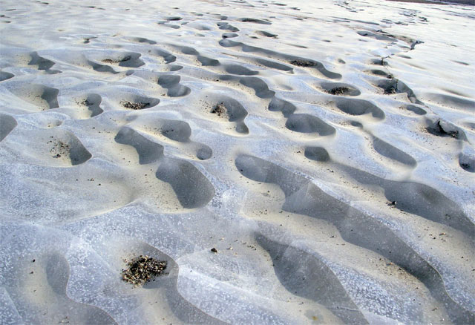
Knowing what you know about the difference in clean and dirty ice melting rates, how do you think those ripples formed?

- Knowing what you know about the albedo effect, as the white Arctic ice disappears and is replaced by the dark ocean below, what will happen to the Arctic Ocean temperatures? Why does this happen?

