Soil Study

Sample | Description | pH | Water Volume Before (mL) | Water in Beaker (mL) | Water Absorbed by Soil (mL)
1 |  |  | 100
2 |  |  | 100
3 |  |  | 100

ANALYZING YOUR pH DATA

1. Were any samples acidic? Which ones?

2. Were any samples basic? Which ones?

3. Were any samples neutral? Which ones?

4. Reflect on all your soil samples, does soil tend to be more acidic, basic or neutral? Why do you think that is?

ANALYZING YOUR WATER ABSORPTION DATA

5. Which soil samples held the most water?

6. How does a soil's ability to hold water relate to soil erosion?

CONCLUSION

7. So what do you think are characteristics of good soil?

Students should already be familiar with pH values, this table below is for your reference.
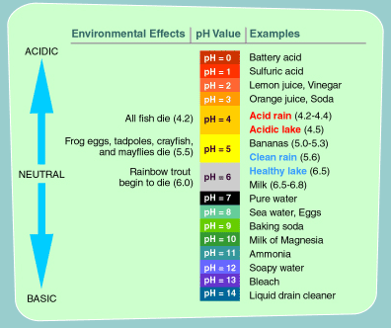
source: United States Environmental Protection Agency

